**Lesson 4 Demo 3**

**Understand Pod Lifecycle**



Steps to be followed:

1. Describing the pod to understand its lifecycle

**Step 1: Describing the pod to understand its lifecycle**

1. Navigate to deployments folder:

***cd deployments***

1. Enter the following command to check the details of a pod:

***kubectl describe pod webserver -n twitter***

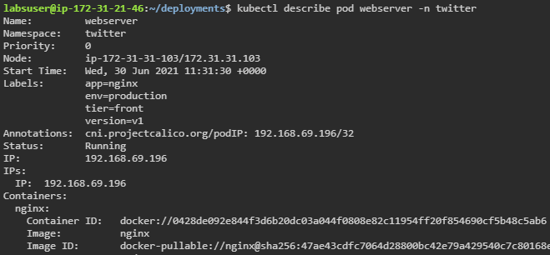

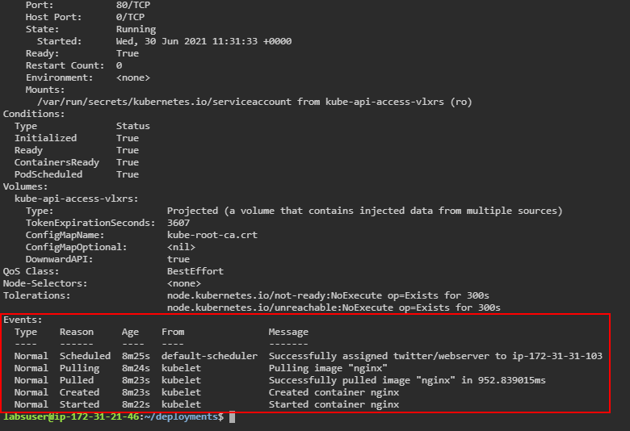

| **Note:** This command helps in understanding the life cycle of the pod **webserver** created in the last demo. Check the **Events** section in the above screenshot. |
| --- |